Install Python3 on your VM.

Identify that one line python command to start and serve static web pages

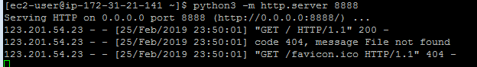

Create a minimal Hello World html file

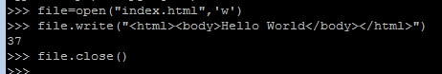

Start the server

On your local machine, open up chrome and access the page using the url http://<ip_address>:8888.

Make note that page should be served on port 8888

